

Mobile App Development
Proposal Template
Prepared for:
[Client.FirstName] [Client.LastName], [Company Name]
Prepared by:
[Sender.FirstName] [Sender.LastName], [Sender Company]
Prepared on: [Date] Valid until: [Date]

Nice to Meet You!

Dear [Client Name],

It's our pleasure to introduce you to [Agency Name] and our team. It's great to have the opportunity to work with you on your mobile application. We'll do our best to provide enough details in this Proposal, so you have a clear understanding of the work process, final deliverables, and how your ideas will be translated into mobile design and code.

As you read through this document some questions or ideas may come to mind, please, don't hesitate to ask or share those with us. Client feedback is of great importance for us. It allows us to better understand our clients' needs and improve on aspects and details that are important for you.

Thanks,
[Agency Name]
[Manager Name]
[Agency Email]
[Agency Phone]

App Development

This square here is to introduce the person who'll be responsible for the client's project. It's important that you show the human face of your agency and that you are not a faceless team of disposable programmers. Listen to your client and ask follow-up questions. Show interest in their business, the challenges they have, and try to think how your work with them will contribute to their bottom line. You can insert a short bio for the dedicated project manager and even a nice photo.

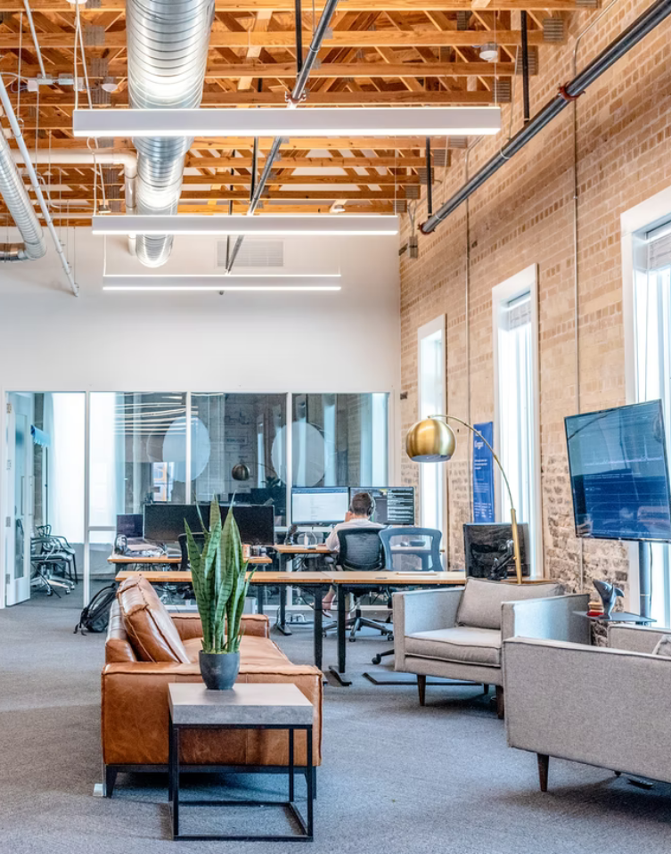 | 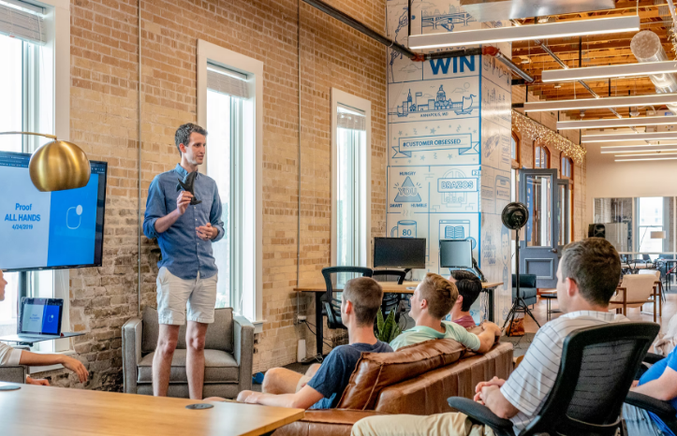
 | 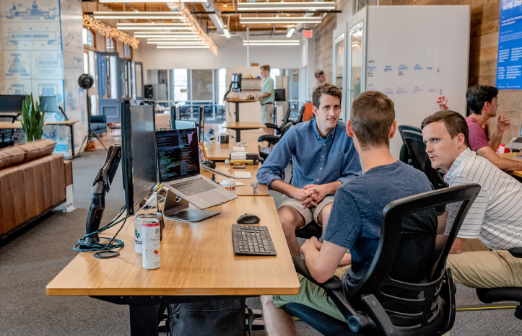

The modern internet user is the mobile internet user. Everything you want to access the internet for is now accessible through your smartphone/tablet. There is a mobile application for every single service you can imagine - from booking hotels and concert tickets to buying cars and real estate. Whatever you're looking for on the internet there's a mobile application for it.

[Agency Name] was found when mobile applications were in their infancy. We grew with the industry and established ourselves as one of the leading mobile applications development agencies in the (City, State, or Country). The greater part of our programming team consists of engineers with 5+ years of active mobile development experience, while new colleagues are joining us all the time bringing new energy and new ideas with them.

Our Expertise

We are serious about what we do and we put a lot of effort into our work. We know that delivering a bug-free application that works flawlessly on every modern smartphone or tablet requires great programming skills as well as thorough testing and upgrades.
Our engineers will be working on your mobile application, while your dedicated project manager will be in contact with you to communicate the development progress and discuss any change requests and additions.

Detailed  Project Brief | We will sit with you and put together a detailed project brief about how you envision your mobile application. In order for us to create the mobile app that will work best for you, we'll need to know in detail what you expect from it and how you want it to entertain, engage or convert your prospects to paid clients.  We'll have to get a better understanding of your business, your main competitors, their mobile applications, and the different types of buying personas that you interact with. Once all this is in place, we'll be able to start with the mobile application design.
App Design | At this stage, we'll have to work on your mobile application design. This is when we'll create the structure of the app. It's very important that all details are cleared while we're working on the design, instead of going back to them when the development has started.  The design of the mobile application has to be consistent with your overall brand image and the design of the rest of the digital marketing channels that you have developed for your business - website, marketing emails, social media presence.  At the design stage, we'll work on the UX and UI for your mobile application. In general, this is how the user interacts with the application, how easy to access its menus is and how engaging the app is.
App Development | At this stage, your work is done and the programming has started. Hopefully, all details are cleared and no changes will be suggested as we work on the programming. Most probably the communication will slow down substantially, as we'll need bigger chunks of time to present any meaningful, visual results. After the mobile application development is completed we'll pass the app to you and to our QA team for testing and bug fixing.
QA Round & Marketing Plan | We are at the final stretch. At the Quality Assurance stage, we'll thoroughly test the application to make sure that everything works as per your specifications.  However, a bigger concern is how will people know that you've launched a new mobile application. It's time to do some marketing planning.  We'll have to sit together again and have our marketing strategists and your marketing team collaborate and prepare the best marketing campaign for your mobile app launch.
Project Schedule | A ballpark estimate is that it will take 30 working days to design, develop and test your mobile application. We're ready to start work as soon as you accept this Proposal. Here's a breakdown of how much time each stage of the mobile app development process will take:
  Project Stages | Time
  Project Brief Review | 3 days
  Design Stage | 10 days
  Programming Stage | 15 days
  QA and Marketing Plan | 5-6 days

Project Costs

One of our goals when working with you is to give you maximum value for your money. Find below a breakdown of the projected development costs. Let us know if you want to comment on this point before you sign the Proposal.

Name | Price | QTY | Subtotal
App Designs | $0.00 | 1 | $0.00
App Development | $0.00 | 1 | $0.00
Marketing Plan | $0.00 | 1 | $0.00
Subtotal:  Government Tax 10%:  Total: |  |  | $00.00  $0.00  $0.00

Payment Terms

We usually split the project payments into three installments. The first two should be paid upfront and the last one upon project completion: Payment 1. Before starting the design phase. Payment 2. Before starting the programming phase. Payment 3. Upon mobile application launch.

All invoices will be issued in USD. Our accounts receivable team will expect your payment within a 30 day period of the issue date on the invoice.

Change Requests
Any changes in the agreed project scope may affect the project costs and will delay the project completion.

NDA
Any information exchanged between [Agency name] and [Client Company] during the process of this mobile application development must be considered confidential. No project details should be shared outside the two teams engaged in this project. The employees of both companies should have NDAs signed in place, before the start of the project. Confidential information won't be considered such if it's already publicly available or if any of the parties already have possession of this said information.

Agreement
By signing below, you agree to accept this proposal for mobile app development and any modifications already agreed upon with [Sender.Company].

[Sender Company]    11 Jan 2022  [Sender.FirstName] [Sender.LastName] | [Client Company]    11 Jan 2022  [Client.FirstName] [Client.LastName]

