

Digital Marketing Proposal

Date: [Date]

Created by.
[Sender.FirstName] [Sender.LastName]
[Sender.Company]

Prepared for
[Client.FirstName] [Client.LastName]
[Client.Company]

Introduction
I’m excited to introduce [Sender.Company] and share how we can help elevate your digital presence. This proposal outlines our approach, the marketing services we provide, and a tailored plan built specifically around your goals.
From our previous discussions, it’s clear that we share a similar vision for what success looks like. My team and I are confident that our strategies can deliver measurable results and help your brand grow in the right direction.
You’ll find a detailed pricing section at the end of this document, covering the services we’ve talked about so far. If you’d like to adjust or customize any part of it, simply leave a comment, and I’ll update the proposal to fit your exact needs.
Once you’re satisfied with the services and pricing, just add your e-signature at the bottom, and we’ll get started on bringing your digital marketing plan to life.

About Us



[Sender.Company] is a results-driven digital marketing agency based in Austin, Texas.
In today’s fast-evolving digital landscape, having the right marketing partner can make all the difference. [Sender.Company] blends creativity with data-driven insights to craft strategies that help brands stand out, build lasting connections with their audience, and achieve sustainable growth across every digital channel.

Our Services
[Sender.Company] is a full-spectrum digital marketing partner dedicated to helping brands grow with clarity and confidence. Whether you’re looking for a complete managed strategy, a one-time audit, or campaign-specific support, our experienced team crafts solutions designed to deliver measurable impact.
Our core expertise includes:
- Website Design & Development – Creating fast, user-friendly, and conversion-focused websites that reflect your brand identity.
- Social Media Marketing – Building authentic engagement and visibility across the platforms that matter most.
- Search Engine Optimization (SEO) – Driving sustainable traffic and improving rankings through ethical, data-driven strategies.
- Pay-Per-Click Advertising (PPC) – Maximizing ROI with precisely targeted campaigns and continuous optimization.
- Digital Content & Video Production – Producing compelling stories and visuals that inspire your audience to take action.
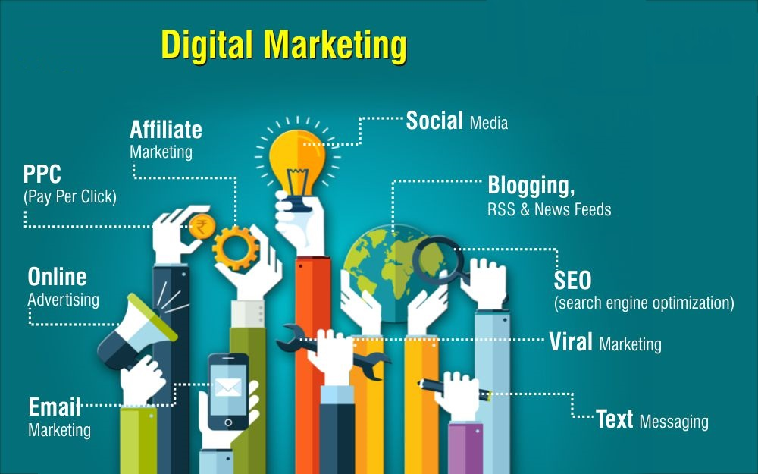

- Web Design & Development
Your website isn’t just a digital address, it’s your brand’s home online. It’s where your story is told, your credibility is built, and your audience decides whether to stay or move on. At [Sender.Company], we create websites that combine striking visuals, seamless functionality, and clear messaging to leave a lasting impression.
Our design and development experts craft each website from the ground up, blending creativity with strategy. Every element from structure to design language is shaped to reflect your brand personality while ensuring speed, accessibility, and performance.
Already have a site that’s not hitting the mark?
We’ll dig in with a full-scale audit to uncover what’s holding it back, then optimize everything from user flow to technical responsiveness, so your digital presence performs as powerfully as it looks.

- Social Media
Social media has transformed the way brands connect with their audiences. Whether you are a B2B or B2C company, it offers an unmatched opportunity to build awareness, strengthen your reputation, and engage directly with potential customers.
At [Sender.Company], we design social media strategies that go beyond likes and shares. Our campaigns focus on meaningful engagement, community growth, and measurable business outcomes. We help you create a strong brand voice, nurture loyal audiences, and turn followers into advocates.
Our social media services include:
- Social Strategy Development
- Social Media Consulting
- Social Media Advertising
- Community Engagement
Our data-driven approach ensures you clearly understand the return on every social initiative. We continuously analyze performance and optimize campaigns to deliver the best possible results for your brand.

- Search Engine Optimization
Every day, billions of searches begin with a simple question. Standing out among countless websites requires more than keywords — it demands strategy, precision, and technical expertise.
At [Sender.Company], we use a research-backed, ethical approach to SEO that helps your brand climb search rankings and stay there. Our goal is to make your website more discoverable, relevant, and trusted by both users and search engines.
Our SEO services include:
- Keyword Research
- Technical SEO
- Full SEO Audits
- SEO Consulting
We combine data insights with creative optimization techniques to attract the right audience, increase organic visibility, and convert traffic into lasting growth.

Pay Per Click
Every day, millions of people search online for products and services like yours. Pay Per Click (PPC) advertising helps your brand appear exactly where those customers are looking — at the top of search results. This targeted approach delivers instant visibility and drives qualified traffic to your website.
At [Sender.Company], we craft PPC campaigns that are both strategic and results-driven. From keyword research to real-time optimization, our team ensures every click brings you closer to conversion and growth. We don’t just aim for clicks — we aim for measurable returns.
Our PPC solutions include:
- PPC Strategy Development
- Market and Keyword Research
- Campaign Setup and Management
- Custom PPC Campaigns
- Continuous Optimization and Reporting
Our approach is data-focused and transparent, helping you make informed decisions and maximize every dollar of your ad spend.

Digital Content & Video
In today’s digital era, content isn’t just king — it’s the driving force behind brand success. The right content can inspire, educate, and move audiences to take action.
At [Sender.Company], we partner with brands to create purposeful content that captures attention and drives engagement. From storytelling videos to dynamic digital assets, we design content that not only looks great but also performs effectively across platforms.
Our content creation services include:
- Digital Content Strategy
- Creative Content Production
- Video Storytelling and Editing
- Visual and Graphic Design
- Multilingual Content Development
Whether it’s an engaging social video, a detailed explainer, or a visually rich campaign, [Sender.Company] ensures your message connects, converts, and leaves a lasting impression.

YOUR CUSTOM DIGITAL MARKETING PACKAGE
Below is a tailored breakdown of digital marketing services recommended for your business based on our earlier discussions. Each item is designed to strengthen your online visibility, optimize performance, and deliver measurable growth.
If you have any questions or would like to make adjustments, simply leave a note beside this section, I’ll be notified right away.
Once you’re happy with the services and pricing, please sign electronically at the bottom of this proposal. After your signature is received, I’ll reach out to schedule a brief onboarding call to kick things off.
Name | Price | QTY | Subtotal
Keyword Research | $550.00 | 1 | $550.00
SEO Audit & Strategy | $1,750.00 | 1 | $1,750.00
PPC Campaign Setup | $625.00 | 1 | $625.00
Monthly PPC Campaign Management | $325.00 | 6 | $1,950.00
 |  | Subtotal | $4,875.00
 |  | Discount (5%) | –$243.75
 |  | Tax | $0.00
 |  | Total | $4,631.25

Acceptance

[Client Company]



11 Jan 2022

[Client.FirstName] [Client.LastName]

[Client Company]

11 Jan 2022

[Client.FirstName] [Client.LastName]

The purpose of this digital marketing proposal is to give you a bit of information about [Sender.Company] and the various digital marketing services we offer, along with information and pricing for a custom digital marketing solution based on your needs. Based on our previous discussion, I feel like we are a good fit for one another. I've spoken with my team, and they're excited to get to work helping you reach your marketing goals.
At the end of this document, you'll find a pricing table that includes the services we've discussed previously. If after reviewing our full list of services you feel like the items in the pricing table don't fit your needs appropriately, just send me a comment (to the right) and I'll make any necessary changes.
The purpose of this digital marketing proposal is to give you a bit of information about [Sender.Company] and the various digital marketing services we offer, along with information and pricing for a custom digital marketing solution based on your needs. Based on our previous discussion, I feel like we are a good fit for one another. I've spoken with my team, and they're excited to get to work helping you reach your marketing goals.
At the end of this document, you'll find a pricing table that includes the services we've discussed previously. If after reviewing our full list of services you feel like the items in the pricing table don't fit your needs appropriately, just send me a comment (to the right) and I'll make any necessary changes.
The purpose of this digital marketing proposal is to give you a bit of information about [Sender.Company] and the various digital marketing services we offer, along with information and pricing for a custom digital marketing solution based on your needs. Based on our previous discussion, I feel like we are a good fit for one another. I've spoken with my team, and they're excited to get to work helping you reach your marketing goals.
At the end of this document, you'll find a pricing table that includes the services we've discussed previously. If after reviewing our full list of services you feel like the items in the pricing table don't fit your needs appropriately, just send me a comment (to the right) and I'll make any necessary changes.

