
Car Sale

Agreement

Template

PREPARED FOR
John Smith

PREPARED BY
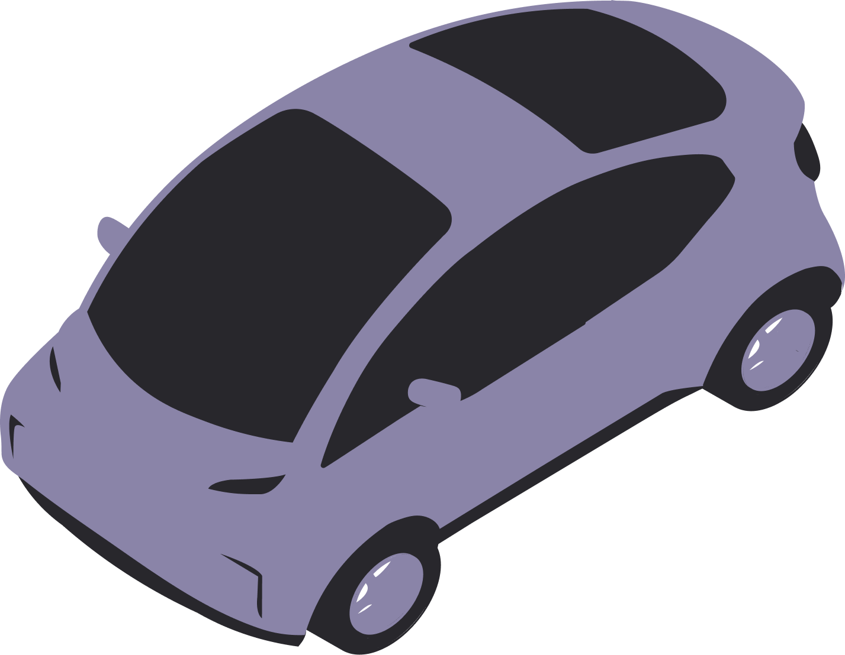
Mark Perlson

Introduction
This Car Sale Agreement (the “Agreement”) is entered into by and between Mark Perlson of 123 Apple Street, CA 10008 (the “Seller”) and John Smith of 321 Orange Avenue, CA 10009 (the “Buyer”). The Seller agrees to sell, and the Buyer agrees to purchase the Vehicle described herein, on the terms and conditions set out below.

Key Definitions
  - “Vehicle” means the Car identified in Section 8 below.
  - “Purchase Price” means the total amount payable by the Buyer to the Seller for the Vehicle.
  - “Delivery” means the handover of possession, keys, and required documents to the Buyer.

Seller Obligations
The Seller covenants and represents as follows:

- Title & Authority: The Seller is the sole legal owner of the Vehicle and has full authority to sell it. The Vehicle is free of all liens, charges, security interests, and other encumbrances, except as expressly disclosed in writing to the Buyer.
- Accurate Disclosure: To the best of the Seller’s knowledge, all information provided about the Vehicle (including make/model, VIN, mileage, prior accidents, flood/fire/salvage history, recalls, and major repairs) is true and complete.
- Odometer Statement: The mileage shown on the odometer is the actual mileage of the Vehicle unless otherwise disclosed as 'exceeds mechanical limits' or 'not actual mileage'.
- Keys & Accessories: On Delivery, the Seller will provide all available keys/fobs, manuals, and accessories normally supplied with the Vehicle.
- Documents: On Delivery, the Seller will provide the properly endorsed title/registration certificate, a bill of sale/receipt, any lien release(s), and any available service records.
- Condition at Delivery: Until Delivery, the Seller shall bear the risk of loss and maintain the Vehicle in substantially the same condition as inspected by the Buyer, ordinary wear excepted.
- Repairs/Recalls: Any open safety recall known to the Seller will be disclosed. The Seller makes no promise to perform repairs unless expressly stated in this Agreement.

Buyer Obligations
The Buyer agrees as follows:
- Inspection: The Buyer has had the opportunity to inspect and/or professionally evaluate the Vehicle and accepts it in its present condition, subject only to any written warranties stated in this Agreement.
- Payment: The Buyer shall pay the Purchase Price in the manner and on the schedule set out in Section 5.
- Transfer & Fees: The Buyer shall complete the transfer of title and registration of the Vehicle with the California Department of Motor Vehicles (DMV) within the time period required under applicable California law following Delivery. The Buyer is responsible for all applicable taxes, registration fees, and insurance associated with the Vehicle.
- Notice of Transfer: The Buyer acknowledges responsibility for submitting any required notice of ownership transfer to the relevant transportation or vehicle registration authority in accordance with applicable legal requirements.
- No Reliance: The Buyer acknowledges that no oral statements outside this written Agreement are relied upon.

Payment Terms
The Buyer shall pay the Purchase Price as follows:
- (a) a deposit of $__________ upon signing of this Agreement; and
(b) the remaining balance of $__________ on or before the Delivery Date.
- Payment shall be made by ____________________.
- Non‑payment: If the Buyer fails to make payment as agreed, the Seller may terminate this Agreement and retain any deposit to the extent permitted by law, without prejudice to any additional remedies available.

Vehicle Condition & Warranties
Select one of the following:
AS‑IS, NO WARRANTY: Unless a written warranty is expressly provided, the Vehicle is sold on an “as-is” basis, with all faults. The Buyer accepts the Vehicle in its present condition and assumes responsibility for all repairs and maintenance after Delivery. The Buyer acknowledges that the sale of the Vehicle is final upon Delivery. Except as expressly stated in this Agreement, the Buyer has no right to cancel or return the Vehicle after acceptance.

LIMITED WARRANTY: The Seller provides a limited warranty covering systems/parts for Number months or Number miles from Delivery. Remedies are limited to repair or reimbursement up to Cap.
BUYER AUTHORITY: The person executing this Agreement on behalf of the Buyer confirms that they are duly authorised and have full legal capacity to bind the Buyer to the terms of this Agreement.
EMISSIONS / INSPECTION DOCUMENTATION: Where required by law, the Seller shall provide the Buyer with any necessary emissions or safety inspection documentation prior to completion of the sale.

Disclosures
- Prior accidents/repairs: Minor rear bumper damage from a low-speed collision in June 2022. Bumper cover replaced and repainted at an authorised service centre. No structural damage reported.
- Liens: No known liens. Vehicle is fully paid off and has a clear title.
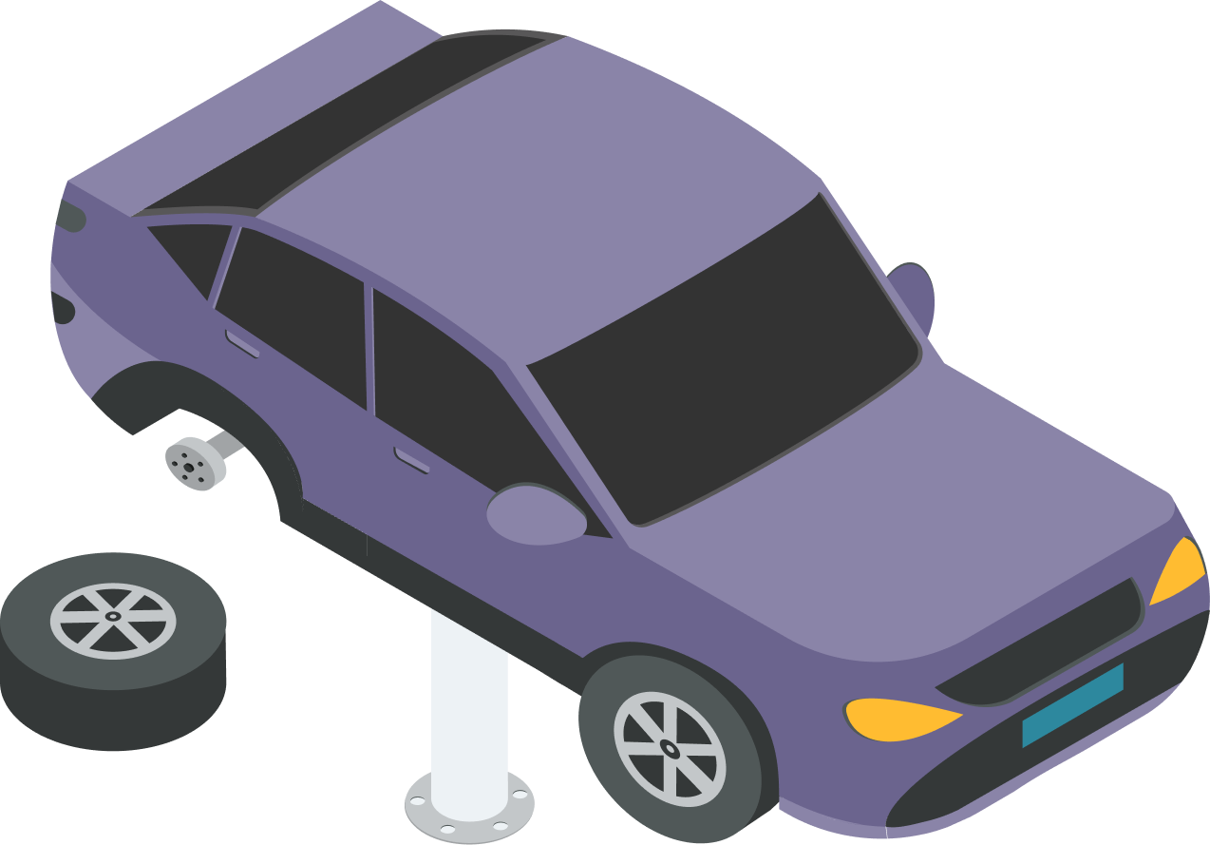
- Other known defects: Small scratch on the left rear door and minor wear on interior upholstery consistent with normal use. No mechanical or electrical issues known at this time.

Vehicle Details
Type of Vehicle | Car
Make & Model | Toyota Prius 2018
Vehicle Identification Number (VIN) | JTDKBRFU0J3587421
Registration/Plate Number | CA 01 AB 4589
Model Year | 2018
Color | White
Odometer Reading | 48,350 Miles
Accessories/Extras | - Reverse parking camera  - Alloy wheels  - Touchscreen infotainment system  - Dual-zone climate control
Agreed Sale Price | $12,500.00

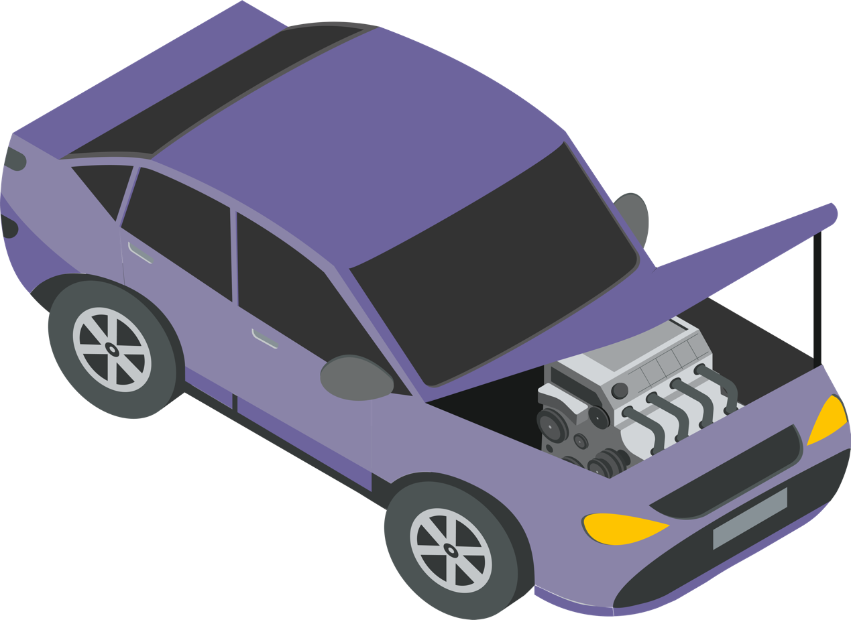

Delivery and Transfer of Title
Delivery shall occur on January 23rd, 2026 at 321 Orange Avenue, CA 10009. Upon receipt of the Purchase Price, the Seller will transfer title and deliver the Vehicle, keys, and documents. Upon Delivery of the Vehicle, the Buyer assumes full responsibility for the Vehicle, including its operation, use, storage, and any liabilities arising thereafter. The Seller shall not be liable for any claims, penalties, or damages occurring after the Delivery Date.

Governing Law & Dispute Resolution
This Agreement shall be governed by and construed in accordance with the laws of the jurisdiction where the sale and transfer of the Vehicle take place. Any dispute will first be addressed through good‑faith negotiation; if unresolved, the parties agree to [mediation/arbitration/court] in that jurisdiction.

General Provisions
This Agreement constitutes the entire understanding between the parties and supersedes prior discussions. Amendments must be in writing and signed by both parties. If any provision is unenforceable, the remainder remains effective.
INDEMNIFICATION AND LEGAL COSTS
If either party materially breaches this Agreement, the non-breaching party may recover any reasonable legal fees and related expenses incurred as a result of that breach. This remedy is in addition to any other rights or remedies available under applicable law.

Signatures
This Agreement may be executed in counterparts, each of which shall be deemed an original, and together shall constitute one binding Agreement.
SELLER | BUYER
Name: Mark Perlson | Name: John Smith
Signature  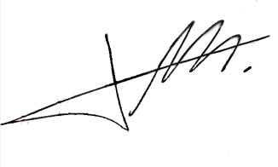 | Signature  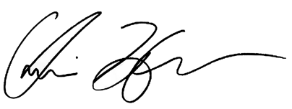
Date: January 06, 2026 | Date: January 08, 2026

